Hackathon - 8 June 2026 – Max ter Steege
On 8 June 2026, I participated in the Deep Learning hackathon together with Jeffrey, Steven, and Alex as team Sigmoid Freud. The challenge was to classify approximately 20,000 legal deeds (aktes) into 32 possible classes, while also taking into account the fact that a deed could belong to multiple classes. One of the other main difficulties was the highly imbalanced dataset, where some of the smaller classes contained only contained 50 examples.
To help teams get started quickly, we received a preprocessed dataset from Raoul, allowing us to focus immediately on model development and experimentation.
Throughout the day, we trained and compared several deep learning techniques, including a simple neural network, a Transformer model, and a Mixture of Experts model. We also experimented with various preprocessing and data handling techniques, such as different chunk sizes and padding methods. All of our training, testing and tuning was logged via a group MLFlow dashboard. See an example of our logging in the figure below.
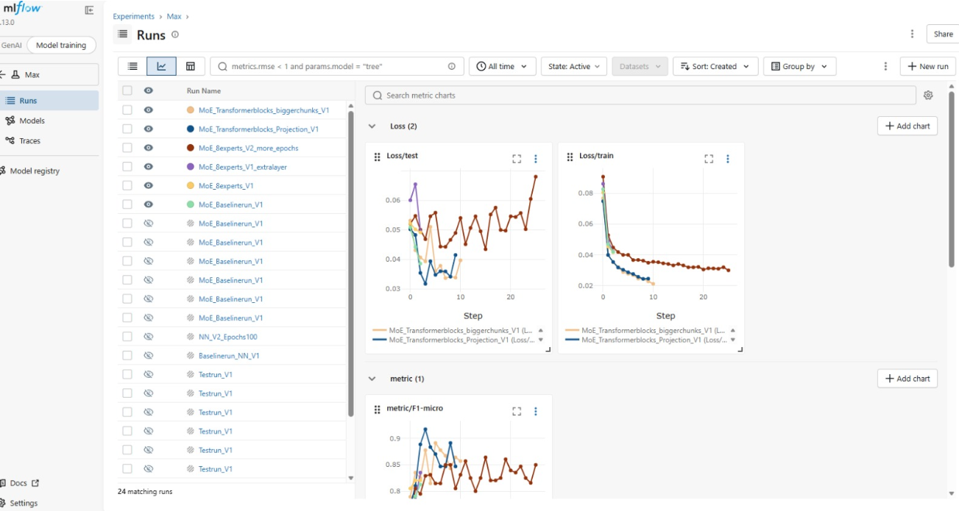
The hackathon started at 09:45 and lasted until 17:00. Afterwards we had pizza and presented our results around 18:00. Overall an interesting day where we learned how to work with an actual dataset from a real company and where acquiring a good result has proven to be quite challenging.

